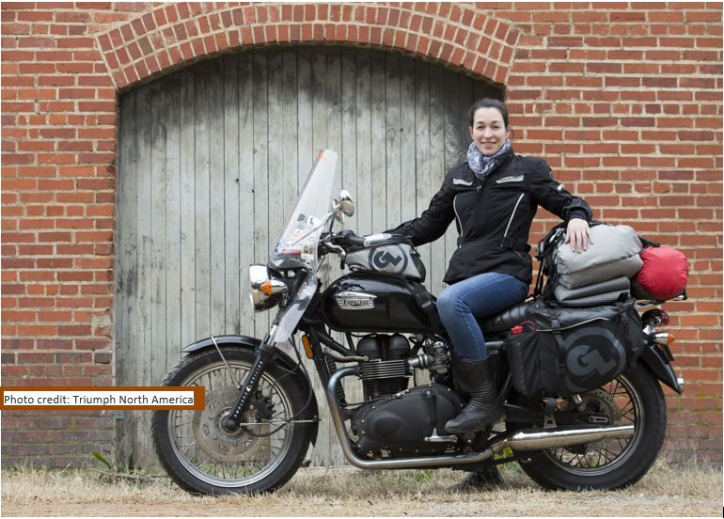
Press Release – For Immediate Release

Black Tie 2 Black Top
– 1 woman, 1 Motorcycle, 1 Year – all 50 States and Canada

**UPDATE- This ride official Broke the Guinness World Record for Longest Journey in Single Country – Danell is the first solo-woman in the world to break this record**

Danell Lynn has been an Arizona Governors Arts Award Nominee in 2011 and 2014, you may know her charity gown created out of AZ Cardinals Game jerseys and signed by the NFC team auctioned for charity, or maybe you know her as an author, designer for dl-couture or for her global philanthropy companies Highwire and Threading Hope…No matter where you may know her from one thing is for sure – this lady definitely has her hand in many areas! What could be next? Why not a year on the road riding her motorcycle through all 50 States and Canada, and of course there will be a book of the adventure. Follow the posted videos and blogs on Blacktie2Blacktop.com

Solo Motorcycle adventure of one woman on a Triumph Bonneville to all 50 states and Canada. While going through the lower 48 she has been accepted by Guinness Book of World Records for an attempt to break the current WR for – ’Longest journey by motorcycle in a single country’, add to that donations to schools in every state classroom copies of her new book Philanthropic Wanderlust – Young Readers Edition (book releases in Aug), and filming a web-series of the adventure. Starting with a departure in Arizona Sept. 19th and heading west to California where she is a selected presenter at the Horizons Unlimited event happening in Yosemite and an official send-off launch on site at the event.

Visiting all the National Parks, camping, hiking, biking…and more. Some may ask why, but throughout Danell Lynn’s life she has always asked why not! So to answer why – “as an avid world travel I want to re-embrace my backyard as an adult -as a child I had traveled to all 50 states but never by 2-wheels! So today I will reach out on a motorbike to a new adventure and a reminder to truly live life to the fullest!”

“Some people see things as they are and say why? I dream things that never were and say, why not?”-Robert F. Kennedy (Interpretation of George Bernard Shaw's words in the play Back to Methusela)

An interview with the rider and adventure traveler Danell Lynn below:

“I wanted to plan an adventure that would open many ideas for me as a writer, humanitarian and traveler.
Some of the ideas that I will be working with / on is providing hand knitted hats to the homeless around the nation and documenting their stories through photographs and videos while on the road “Street Stories.” My hope is to create a captivating book / documentary of the stories from our streets.
Web-series of the rides and National Parks and the adventures that I will encounter along the way.
I also know that I will not take this trip and stay exactly the same. Journeys of this kind add layers to who you are. One thing for sure is currently the road feels like home to me, and maybe, just maybe I will find a spot to homestead … but only time will tell, the road may be my lifetime nature, but maybe there will become a home base, in my backyard.
There are so many reasons when you sit down to take a trip like this, another component for me as a writer and humanitarian is to share the young readers edition of my book Philanthropic Wanderlust with students. I will be doing readings and providing classroom sets with curriculum guides to hopefully, a least 1 school in every US state. Hoping to help provide the stepping stones into philanthropy for future generations.”
Read more on the adventure and follow the digital stories-blogs & video: Blacktie2Blacktop.com
-For more information visit:
www.DanellLynn.com
www.facebook.com/Danell.lynn
@DanellLynn

Photos are attached and Danell is willing to come out for photo shoots specific for your publication or on air for radio, or set for news coverage. Please contact her directly at:
info@dl-couture.com or her cell (not for release only for media contact) 928-699-1605

There is also a selection of photos available for press use at: www.danelllynn.com/media

